Dalton Murray

Systems Analysis and Design

INT 4202 - 1952-202310_INT4203_M

Dr. Anthony Padalino

September 20, 2022

**Week 4 Assignment**

**Interviews and Questionnaires are two common fact-finding methodologies. Briefly describe their similarities and differences. Include comments on when each of these methods should be used.**

Interviews –

In interviewing you need to determine who you are interviewing, establish objectives for the interview, create interview questions, prepare for it, conduct it, document it, and evaluate the interview.

During interviewing you need to ask the right combination of open-ended questions and closed-ended questions.

Usually done in smaller quantities to provide more detailed information.

Interviews are more personal and familiar than a questionnaire.

Interviewee’s may find it easier to explain more critical or controversial topics in-person.

Interviews can be more reactive to answers provided by the interviewee and help clear up any confusion.

Can assist in finding unbiased answers to questions based on reactions.

Can cost much more and be very time consuming.

Must be prepared and can send follow-up questions.

Less convenient for interviewee’s time.

Cannot be anonymous.

Requires skill.

Questions can be easily clarified if questions arise.

(Tilley, S. p. 116-121 & 124-125).

Questionnaires –

In questionnaires it is also important to know who you are sending the questions to, the objectives of the questions, create the questions, send out the questionnaires/surveys, and document and evaluate the questions/results.

You also need to figure out what types of questions to ask if they are questions like on a scale of 1 to 10, or questions which need to be typed in for a response.

Questionnaires are usually sent out to larger quantities of people, can provide detailed information but usually less than interviews.

Less personal and familiar than an interview.

May limit explanations to questions.

Can be reactive/dynamic to responded answers but usually less so than interviews.

Cannot more easily look for biases based on reactions.

Doesn’t cost much and can be done quickly.

Must be prepared and can send follow-up questions.

More convenient for interviewee’s time.

Can be anonymous.

Requires skill.

Questions cannot be easily clarified if questions arise.

(Tilley, S. p. 123-125).

**What is a functional decomposition diagram (FDD) and why would you use one? Explain how to create an FDD.**

A functional decomposition diagram or FDD is a way to show top-down representations of a function or process (Tilley, S. p. 129). In other words, a FDD is a graphical representation of a function or process which starts with a general thing and slowly works its way down getting more and more specific. It is important to use an FDD diagram for analysts so that they can break down business functions or processes in a meaningful and efficient way which allows them to visualize the function or process and allows them to show it to other people to see if they are able to properly understand it, so they know what to do, and so that the analyst can understand the function or process better too (Tilley, S. p. 129). An example of an FDD can be found below:

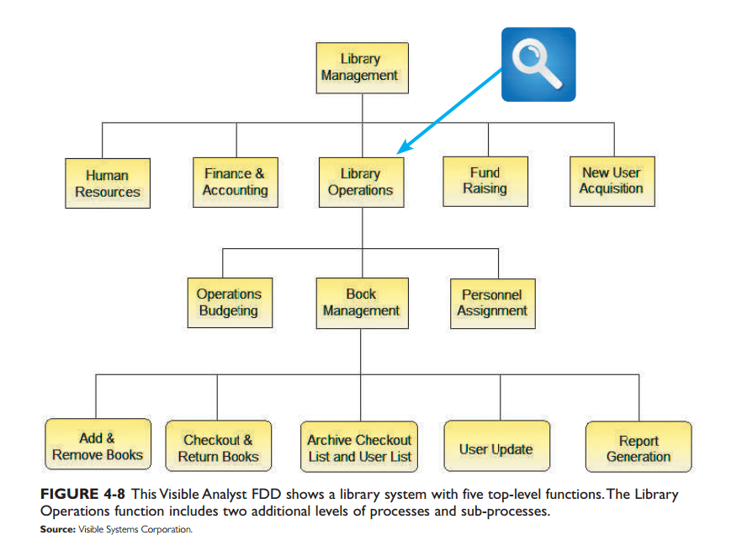

(Tilley, S. p. 130).

The above diagram shows how to properly create an FDD. It starts with something general such as how to manage a library which is then broken down into an HR department, Finance & Accounting, Library operations (further broken down), fund raising, and new user acquisition. This diagram then breaks down what it means by library operations such as operations budgeting, book management, and personnel assignment, then breaks down the book management even further to explain the process of how books are managed.

References

Tilley, S. (2020). Systems analysis and design (12th ed.). Cengage.

I have neither given nor received unauthorized aid in completing this work, nor have I presented someone else's work as my own.

*Dalton Murray*